# **faimGraph**

1. mkdir build
2. cd build
3. cmake ..
4. make -j4

For running the file modify batch size in configuration.xml

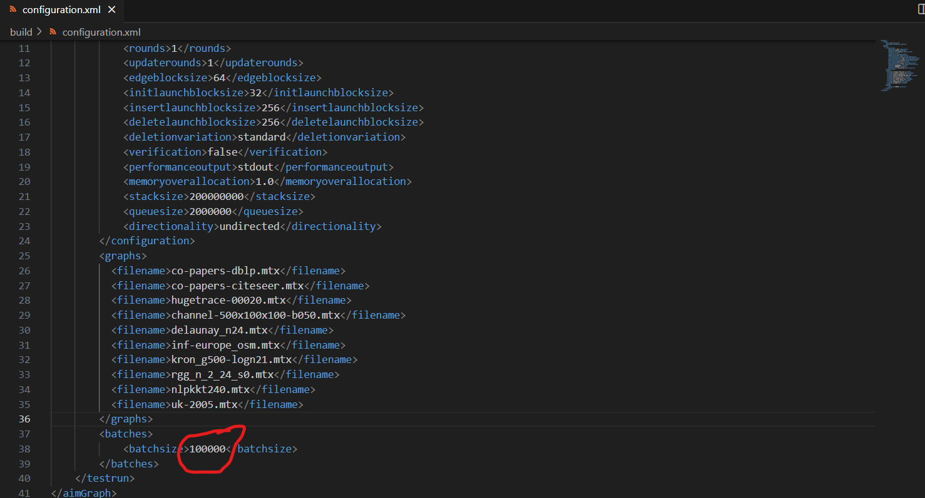

For running the simulation use: ./main configuration.xml

Statistics for all graphs are printed.

1. **Hornet**

Running Hornet:

1. cd /usrdata/iitrpr/temp/t/hornet/hornet/build_test
2. cmake ..
3. Make -j4
4. ./hornet_insert_test filename batchsize
5. ./hornet_delete_test filename batchsize

# **Setting up Gunrock Main Branch**

1. git clone –recursive <https://github.com/gunrock/gunrock.git>
2. Make sure gcc & g++ are set to version 9, nvcc is set to 11.5, cmake version is above 3.24
3. cd gunrock
4. mkdir build && cd build
5. make sssp
6. cd bin
7. Copy input files to this folder
8. ./sssp --market input.mtx

# **Setting up Gunrock dynamic-graph Branch (SlabGraph)**

1. git clone –recursive –branch dynamic-graph <https://github.com/gunrock/gunrock.git>
2. Make sure gcc & g++ are set to version 7, nvcc is set to 10.2, cmake version is above 3.24
3. cd gunrock
4. Install libboost
5. The next setting is A100 specific.
   1. Goto CMakeLists.txt.
   2. Set CUDA_AUTODETECT_GENCODE to OFF.
   3. Set GUNROCK_GENCODE_SM75 to ON.

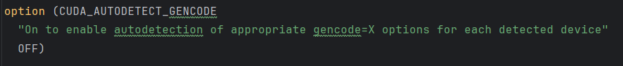

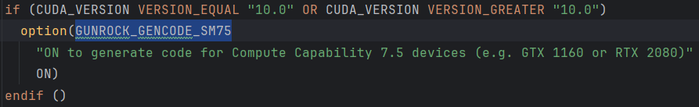

1. mkdir build && cd build
2. cmake ..
3. make sssp
4. cd bin
5. Copy input files to this folder
6. ./sssp market input.mtx

# **Running FaimGraph**

1. For running Static Triangle Counting: Add files in configuration.xml file.
2. cd faimGraph/build
3. ./STC configuration.xml
4. Normal Run: ./main configuration.xml.
5. Make sure to add filenames in configuration.xml. Batch size is also specified in configuration.xml file.

# **Running Hornet**

Make sure that gcc and g++ versions are 7 and cuda version is 10

1. cd hornet/hornetsnest/build
2. For running TC
   1. ./triangle2 file.mtx
3. To run insertion:
   1. cd hornet/hornet/build_test
   2. ./hornet_insert_test filename batchsize